Press release
12 March 2026
Nova sit, a Czech cultural service organisation, launches the new European project Bridging the A-I-R - strengthening residencies for sustainable cultural mobility
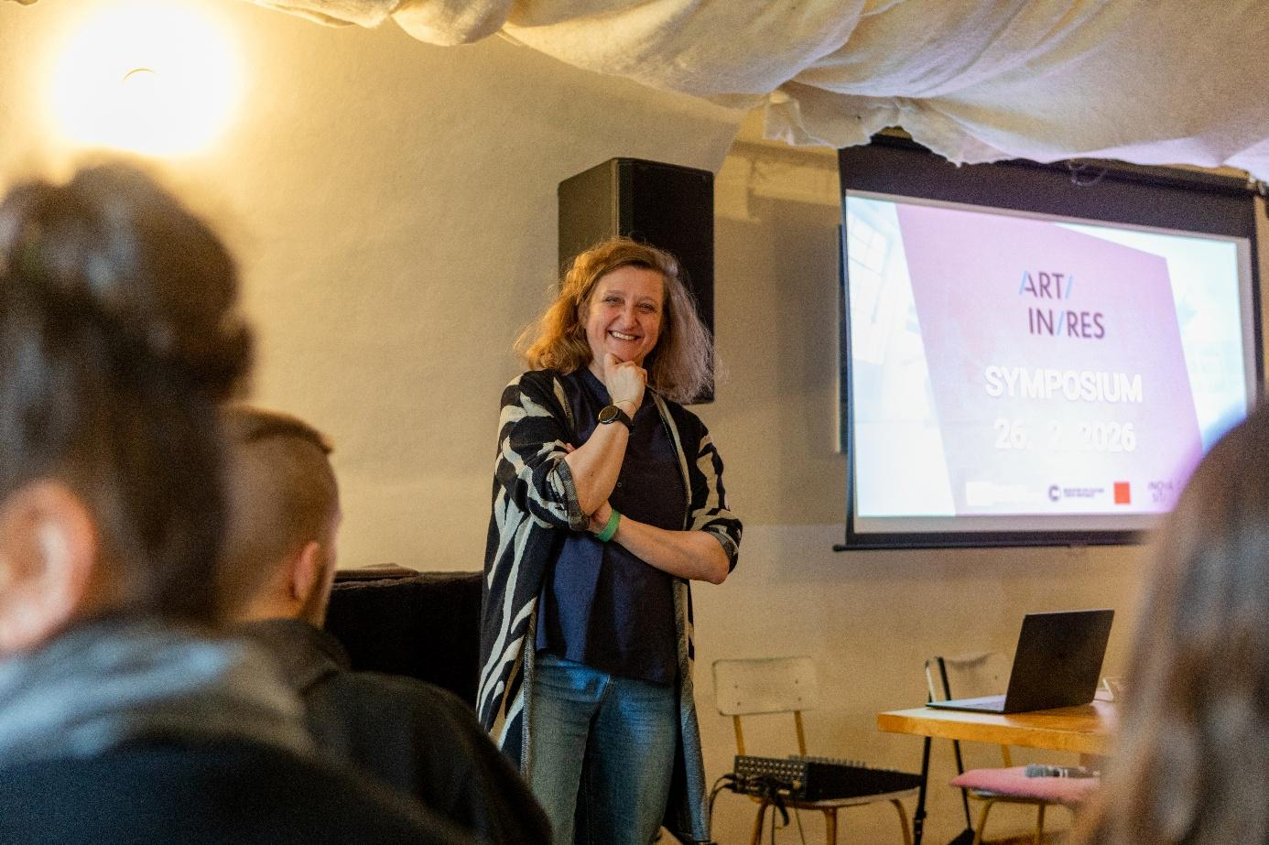
On 26 February 2026, Nová síť presented a new international project, Bridging the A-I-R (BtAIR), during the Malá inventura festival. The project focuses on strengthening artistic residencies and supporting sustainable cultural mobility in Europe. Nová síť acts as the lead partner and, together with partners from five other European countries, will develop cooperation among residency centres over the next four years.
The project was introduced as part of the ART-IN-RES Symposium, which Nová síť organizes annually as a platform for sharing experiences and discussing the current state of artistic residencies in Europe. This year’s edition was dedicated to the launch of the BtAIR project and the meeting of its international partners.
“Artistic residencies have been one of our main areas of focus for more than ten years, and we see how they contribute to the accessibility of culture in the regions and connect artists with often remote places. Thanks to organizations that provide a supportive environment for artistic creation, unique projects emerge that carry the imprint of the place and the people involved in their creation. All of this makes particular sense in a European context,” says Adriana Světlíková, Director of Nová síť.
The project is supported by the Creative Europe programme and will be implemented over a period of 48 months in six European countries.
Main Goals of the BtAIR Project
The BtAIR project focuses on strengthening residency centres across Europe through the sharing of experience, know-how, and the development of common standards for high-quality residency programmes. It connects organizations across Europe and creates a space for exchanging experience across different cultural and regional contexts.
The project also explores more sustainable models of residency programmes that support care, collaboration, and balance between centres and peripheries. At the same time, it aims to contribute to the development of cultural infrastructure outside major cities and to strengthen the decentralization of cultural life in Europe.

Key Activities
The BtAIR project includes several key activities:
- 12 pilot residencies testing new formats (community-based, ecological, or research-oriented) in six countries.
- Development of an online platform for residency collaboration. Slovak and Hungarian versions of the Czech portal artinres.cz will be created, along with a new European hub btair.eu, offering open calls, methodologies, and examples of good practice.
- Practical tools and educational materials for residency centres, including open manuals, case studies, and mentoring programmes for both existing and emerging organizations.
- International symposia and workshops focused on fair conditions in culture and networking.
- A Policy Brief offering recommendations for supporting residency infrastructure at both national and European levels.

International Partnership
The project is led by Nová síť in cooperation with the following partners:
- Slovakia: Anténa - sieť pre nezávislú kultúru
- Italy: IDRA Teatro
- Spain: Teatro de lo Inestable
- Germany: Schloss Bröllin
- Hungary: Swing Jazz Culture Foundation
Strategic partners of the project include Czech Centres and Creative Institute Trenčín 2026.

Symposium Programme
The morning session was dedicated to an internal kick-off meeting of the project partners. The afternoon programme was open to the public and introduced the overall framework of the project, the partner organizations, and the planned activities.
Representatives of international residency centres shared their experiences. Katharina Husemann and Sabine Gehm from Schloss Bröllin presented the functioning of an international residency space located in a heritage-protected complex north of Berlin. Sylvia Huszár from Hungary’s METTRIN Arts Center introduced the activities of the centre located near Lake Bánki, which combines theatre productions, concerts, and international residencies.
The programme also included a presentation on support opportunities for residency stays from the International Visegrad Fund and an introduction to the ART FARM project within the České Budějovice 2028 initiative. The concluding discussion focused on current opportunities for supporting residencies in the Czech Republic and a broader reflection on the conditions for cultural mobility.
On the second day, 27 March, a working meeting with the BtAIR project partners followed, during which key plans and shared objectives were summarized.

Project Context and Next Steps
The BtAIR project responds to the changing conditions in which artists and cultural organizations operate today and seeks ways in which residency programmes can support focused artistic creation, collaboration, and the sharing of experience.
The ART-IN-RES Symposium symbolically launched several years of collaborative work by the partners on the Bridging the A-I-R project. In the coming years, participating organizations will develop pilot residencies, share practical experience, and build the European online hub btair.eu.
The aim of the project is to strengthen the stability of residency centres, share best practices, and support international cooperation in the field of artistic residencies. The progress of the project can be followed at novasit.cz.
Supported by the Ministry of Culture of the Czech Republic and the Prague City Hall.
Funded by the European Union. The views and opinions expressed in this text are those of the authors only and do not necessarily reflect those of the European Union or EACEA. Neither the European Union nor the granting authority can be held responsible for them.
-----------------------------------------------------------------
If you are interested in further information or photographs, please contact:
Magdalena Košárková, PR and Marketing
Tel. +420 601 558 565
magdalenakosarkova@novasit.cz

